Lesson 04 Demo 01

Creating a Virtual Machine in the Azure Portal

Objective: To create a virtual machine of windows server in the Azure portal
Tools Required: None

Prerequisites: None

Steps to be followed:
- Create a virtual machine in the portal

Step 1: Create a virtual machine in the portal

- Sign in to the Azure portal as an administrator

- Under Azure services, select Virtual machines

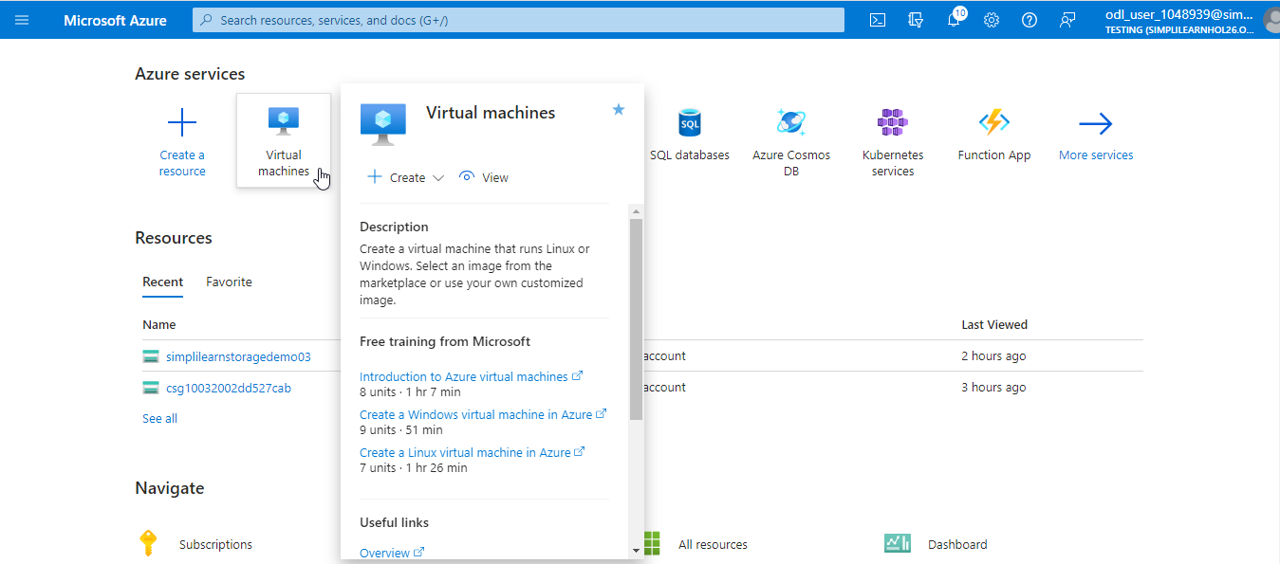

- Navigate to the Virtual machines page, click on + Create, and then select Azure virtual machine. This will open a Create a virtual machine page

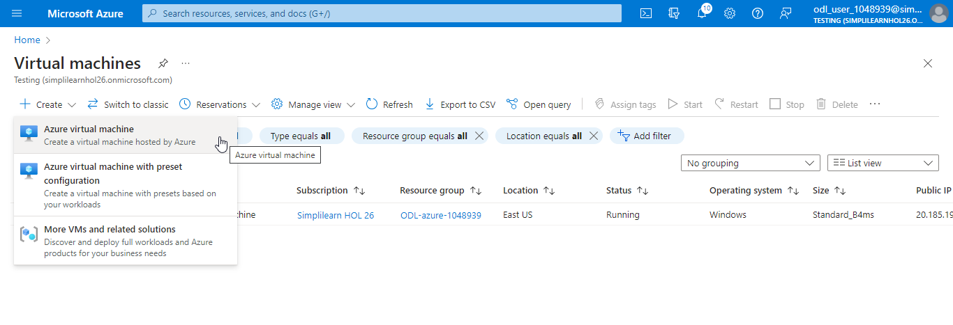

- In the Basics tab, under Project details, make sure the correct subscription is selected and then choose the Create new resource group. Type myResourceGroup as the name

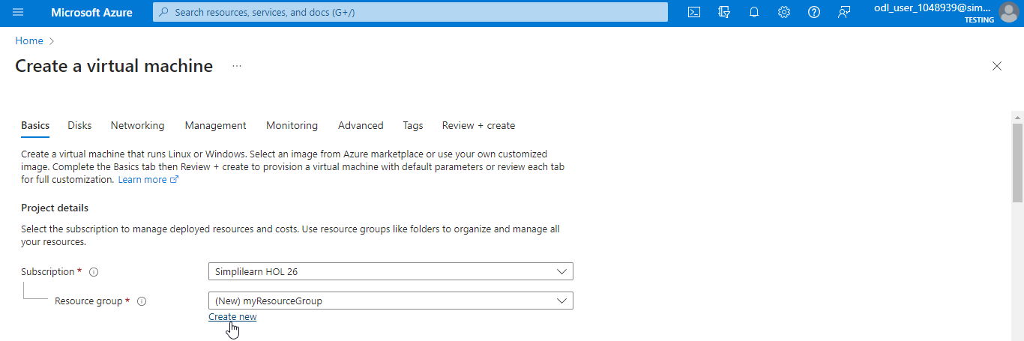

- Under Instance details, type mVM for the Virtual machine name and choose Windows Server 2022 Datacenter - Gen2 for the Image. Leave the others as default

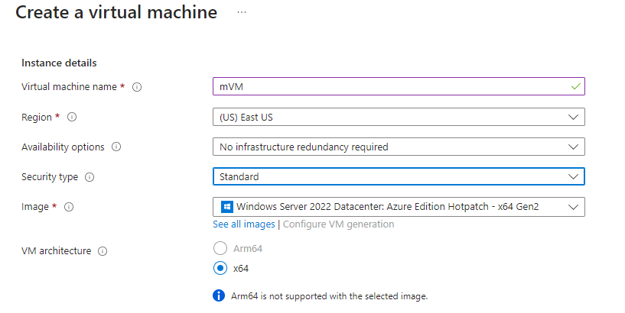

- Under Administrator account, provide a username, such as azureuser, and a password. The password must meet the complexity requirements.

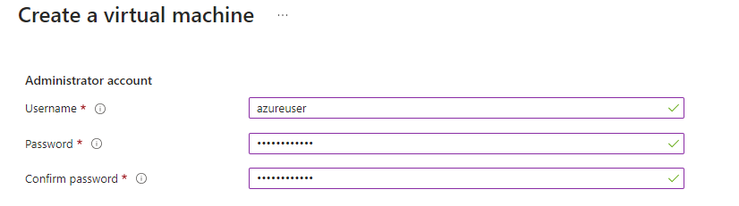

- Under Inbound port rules, choose Allow selected ports and then select HTTP (80) and RDP (3389) from the drop-down

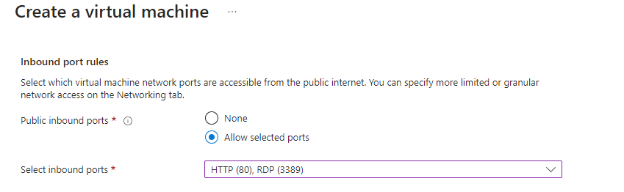
- Leave the remaining as default and then select the Next : Disks > button at the bottom of the page
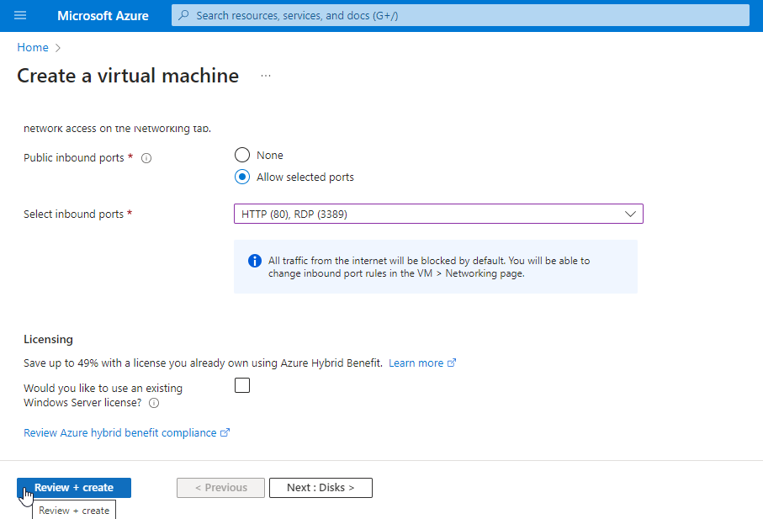

- Navigate to Disks and select Standard HDD as OS disk type and click Review + create
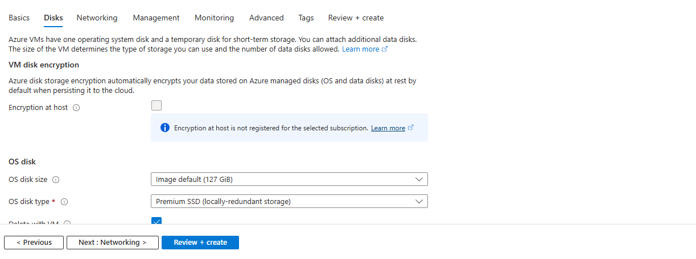
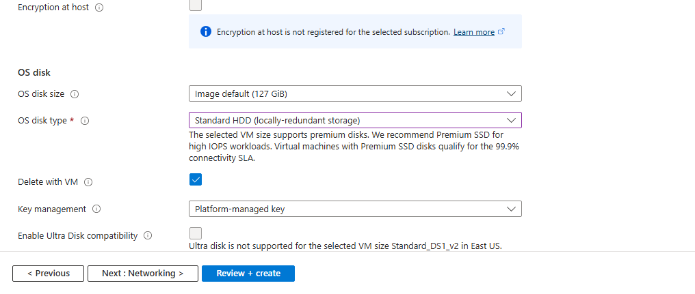
- After the validation is passed, select the Create button at the bottom of the page

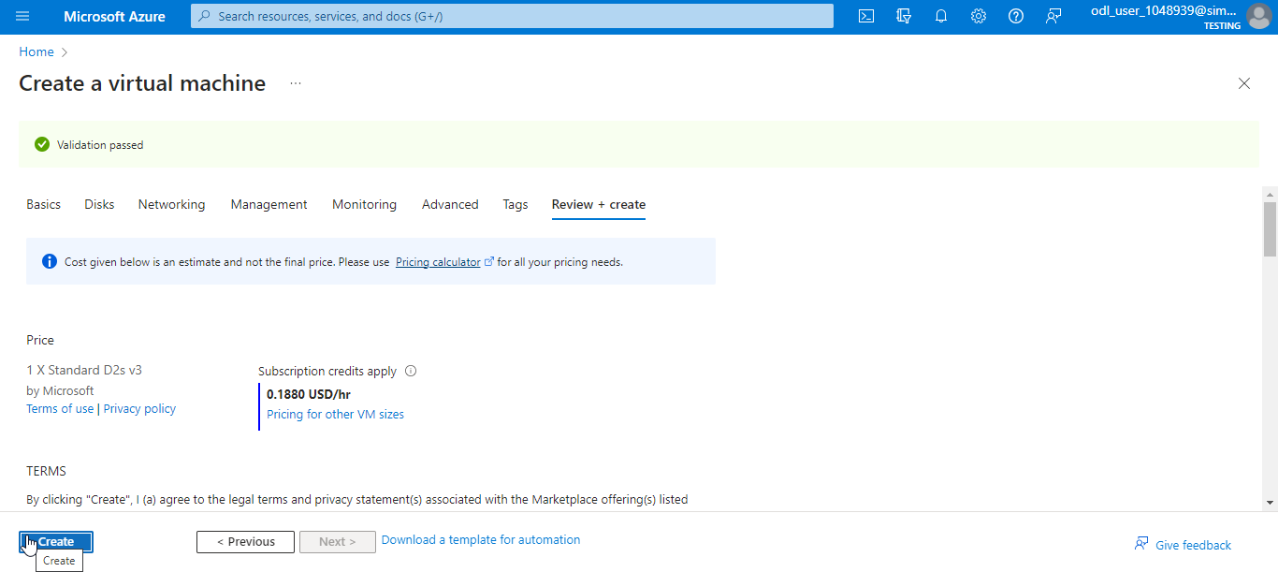

1.11 After deployment is complete, select Go to resource

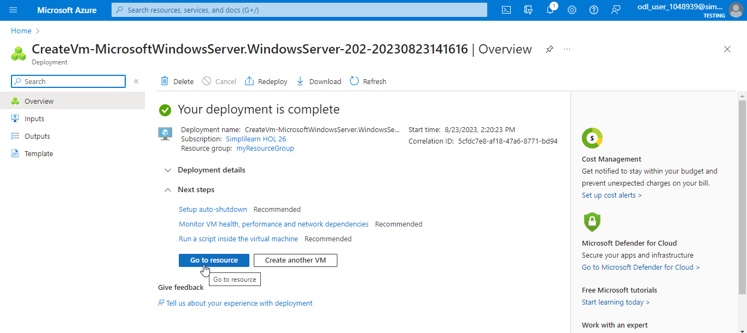

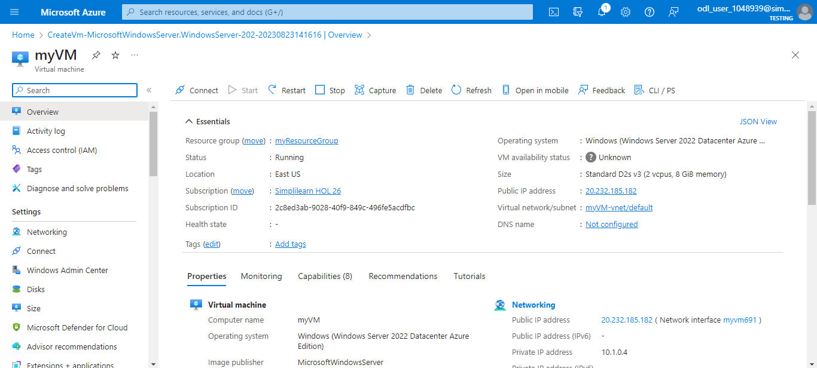

You have now successfully created a Windows-based virtual machine from Azure portal.

